Design and Development of a
Solar E-Bicycle with an Embedded based
Smart Monitoring System


Report submitted to GITAM (Deemed to be University) as a partial fulfillment of the requirements for the award of the Degree of Bachelor of Technology in (write your respective branch)
DEPARTMENT OF ELECTRICAL, ELECTRONICS AND COMMUNICATION ENGINEERING
GITAM SCHOOL OF TECHNOLOGY
GITAM (DEEMED TO BE UNIVERSITY)
BENGALURU -561203
NOV 2025

Name : | Salomi.S  N.Rakshitha
Regd.No. : | BU22EECE0200006  BU22EECE0200019

DECLARATION

We declare that the project work contained in this report is original and it has been done by me under the guidance of my project guide.

Name: Salomi S
N Rakshitha
Date:

DepartmentofElectrical,ElectronicsandCommunicationEngineering GITAM School of Technology, Bengaluru-561203



CERTIFICATE

This is to certify that Salomi S And N Rakshitha bearing BU22EECE0200006 and BU22EECE0200019 has satisfactorily completed MiniProject Entitled in partial fulfillment of the requirements as prescribed by University for VIIth semester, Bachelor of Technology in “Electrical, Electronics and Communication Engineering”and submitted this report during the academic year 2025-2026.

[SignatureoftheGuide] [SignatureofHOD]

Tableofcontents

Chapter1: Introduction 1
  - Overviewoftheproblemstatement1
  - Objectivesandgoals 1
Chapter2:Literature Review 2
Chapter3:StrategicAnalysisandProblemDefinition 3
  - SWOTAnalysis 3
  - ProjectPlan-GANTTChart 3
  - Refinement of problem statement3
Chapter4:Methodology 4
  - Descriptionoftheapproach 4
  - Toolsandtechniquesutilized 4
  - Design considerations 4
Chapter5:Implementation5
  - Descriptionofhowthe projectwasexecuted 5
  - Challengesfacedand solutionsimplemented5
Chapter6:Results6
  - Outcome 6
  - Interpretation of results 6
  - Comparison with existing technologies 6
Chapter7: Conclusion 7
Chapter8 : Future Work 8
References 9

Chapter1:Introduction

  - Overview of the problem statement

Today, people need transportation that is both affordable and eco-friendly. Normal bicycles are good for short trips but require a lot of effort, especially for long distances or uphill rides. On the other hand, fuel-powered vehicles cause pollution, increase fuel expenses, and rely on non-renewable energy.
Electric bicycles solve some of these issues, but they depend on batteries that need frequent charging and electricity from the grid, which is not always clean.
A better option is to use solar energy in electric bicycles. Solar panels can charge the battery using renewable energy, reduce dependence on the power grid, increase travel range, and provide a greener, more practical transport solution for everyday use in cities and towns.

1.2 Objectivesandgoals

Objective:

The main objective of this project is to design and develop a solar-powered electric bicycle that can serve as an affordable, eco-friendly, and practical mode of transport. Unlike traditional bicycles, which require continuous manual pedaling, and fuel-based vehicles, which increase pollution and costs, this bicycle aims to combine renewable energy with electric mobility to create a more sustainable solution.
The system integrates solar panels to harness clean solar energy and charge the bicycle’s battery, reducing dependence on grid electricity and extending the travel range. To enhance user convenience, an IoT-based dashboard is incorporated, which provides real-time monitoring of key parameters such as battery status, speed, distance, and solar charging performance.
Beyond efficiency, the project emphasizes smart and safe urban mobility. By combining solar charging with IoT monitoring, the bicycle supports modern transport needs while promoting environmental sustainability. This design not only addresses the limitations of conventional and electric bicycles but also provides a scalable and sustainable solution for urban and semi-urban transportation.

Goals:

Main Goals
- Solar + plug-in charging (continuous battery)
- BLDC hub motor drive (efficient & sustainable)
- IoT dashboard (battery, speed, distance, solar status)
- Smartphone connectivity (performance data & alerts)

Chapter2: LiteratureReview

Several studies have explored the potential of solar-assisted bicycles and vehicles. T. Suresh (2021) presented techniques for developing solar-powered bicycles, highlighting their role in reducing dependency on conventional energy sources. Similarly, Hema Latha (2019) focused on the design and development of solar-powered vehicles, emphasizing sustainability and efficiency in mobility solutions. More recently, P. Maheswara Rao (2024) implemented practical approaches to solar bicycle design, contributing to advancements in renewable-powered transport. In parallel, Adhisuwignjo (2017) examined e-bike sharing systems, underscoring the importance of integrating smart and accessible transportation models for urban environments.
In terms of technical resources, various guides and datasheets provide essential information for system design. These include BLDC motor and controller specifications, battery management system (BMS) datasheets, and MPPT charge controller documentation. Standards such as IEC 62133, IEEE 1562, and IS guidelines serve as benchmarks to ensure safety, reliability, and performance.
Existing implementations further demonstrate the practical adoption of these systems. Open-source e-bike hardware and software platforms enable customization and scalability, while DIY modular controllers and display units provide flexibility for enthusiasts and developers. Additionally, repositories dedicated to e-bike analytics and instrumentation support data-driven improvements and monitoring, paving the way for smarter and more efficient solar e-bike systems.

Chapter3:Strategic Analysis and Problem Definition

  - SWOT Analysis

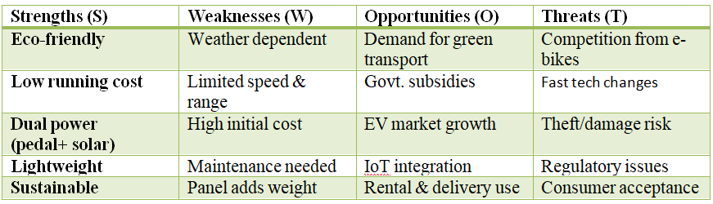

  - ProjectPlan-GANTT Chart

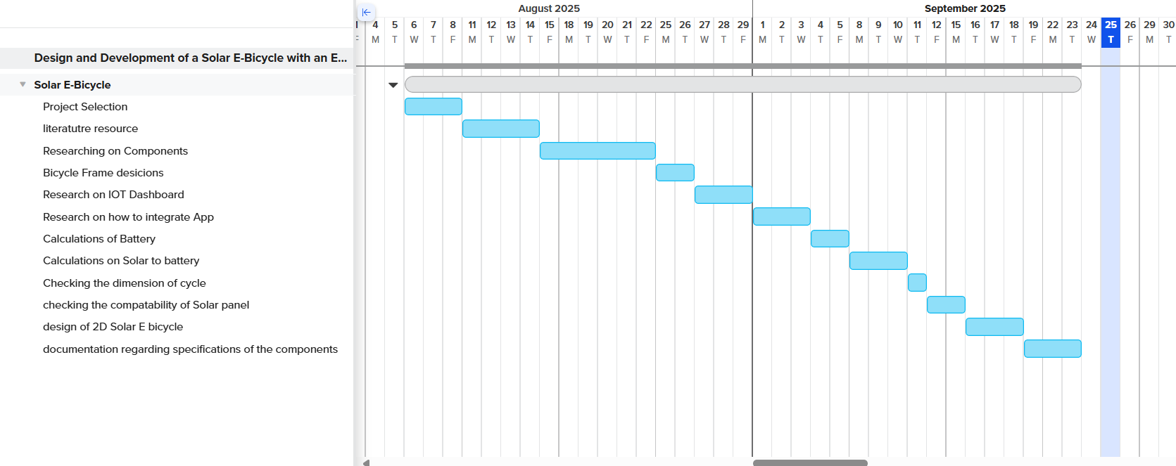
  - Problemstatement

The rising cost of conventional fuel and increasing environmental pollution have created an urgent need for sustainable and eco-friendly transportation solutions. Traditional bicycles, though environmentally friendly, require significant physical effort and are not practical for longer distances or for users with limited physical capability. Electric bicycles offer convenience but depend heavily on electricity from non-renewable sources and require frequent recharging, which increases cost and environmental impact. Therefore, there is a strong need for a transportation alternative that is both energy-efficient and sustainable. A solar-powered bicycle provides a viable solution by utilizing renewable energy, reducing dependence on fossil fuels, lowering operational costs, and offering an efficient, reliable, and environmentally responsible mode of daily commuting.

Chapter4 :Methodology

  - Description of the approach

The methodology for developing the solar-powered bicycle follows a systematic and integrated approach combining mechanical design, electrical components, and software monitoring to achieve efficient and sustainable operation.
- Selection of Components:
  - Solar Panels: Chosen based on power output, size, and weight to efficiently charge the battery.
  - Battery: Selected to store sufficient energy for daily use and to provide backup when sunlight is insufficient.
  - Motor & Controller: Motor capacity is matched with battery output for smooth operation, with a controller to regulate speed and power.
- Energy Management System:
  - A charge controller ensures safe and efficient charging of the battery from solar panels.
  - Sensors monitor battery voltage, current, and temperature for optimal performance and safety.
- Mechanical Design:
  - Bicycle frame is modified to accommodate solar panels and battery without affecting stability.
  - Design ensures lightweight construction and rider comfort.
- IoT & Software Integration:
  - IoT-enabled system tracks battery level, speed, and overall performance in real-time.
  - Data is displayed on a dashboard or mobile app for user convenience.

- Testing and Calibration:
1. Solar Charging Efficiency Issues
Challenge: Insufficient charging on cloudy days.
Solution: Panel angle optimized and MPPT controller used to improve charging efficiency.
2. ESP32 Noise Interference
Challenge: Electrical noise from the motor caused unstable sensor readings.
Solution: Added filter capacitors and improved grounding.
3. Mechanical Mounting Problems
Challenge: Solar panel mounting introduced vibration.
Solution: Customized metal brackets with rubber damping pads were installed.
4. Battery Heating During Long Rides
Challenge: Battery temperature increased after extended use.
Solution: Ventilated casing and temperature monitoring via ESP32 added.
5. Calibration of Speed & Voltage Sensors
Challenge: Sensors gave inaccurate readings initially.
Solution: ESP32 code adjusted, and sensors recalibrated through trial testing.

4.2 Tools and techniques utilized

1. Brushless DC Hub Motor (BLDC)



Type : Brushless DC (BLDC) Hub Motor
Voltage rating : 36V
Power rating : 250W

36V BLDC Motor Controller
2. BLDC Motor Controller
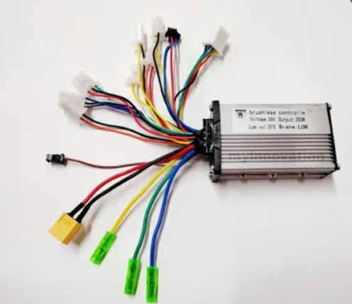

3. Solar Panel

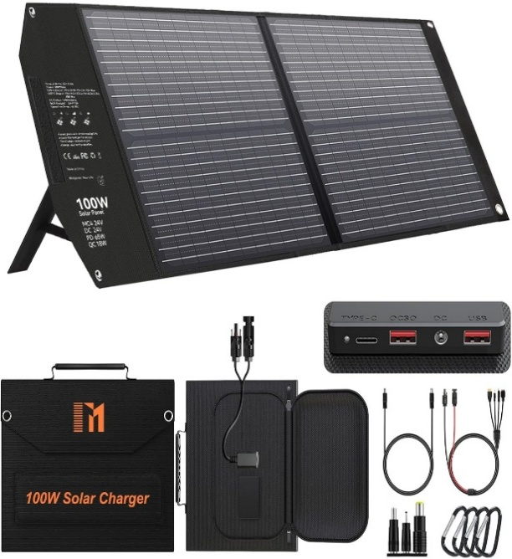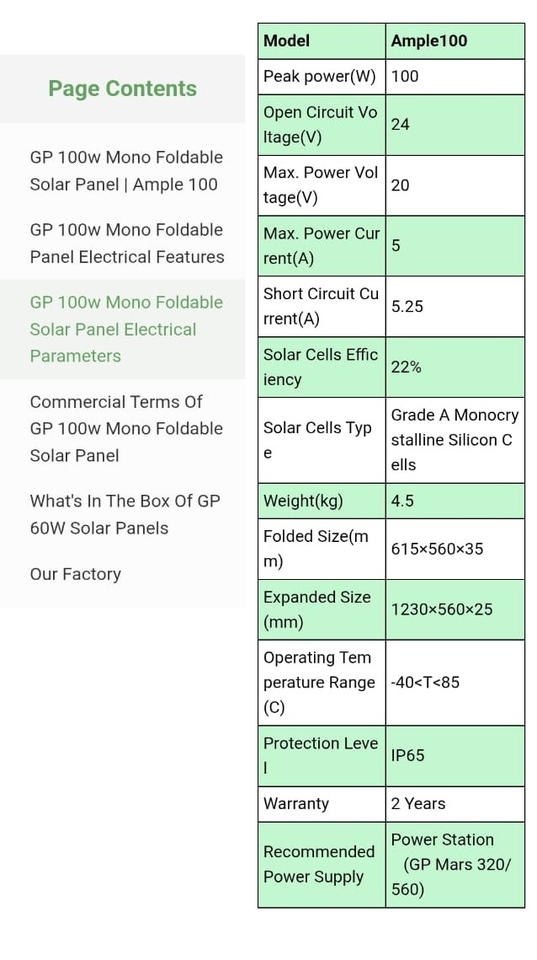

4. Battery

Type : Lithium ion battery
Voltage : 36V
Capacity : 12 Ah

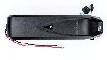

5. ESP32
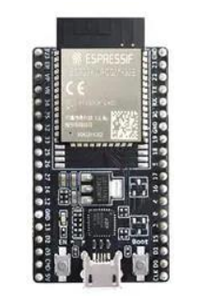
Brand
oceanlabz
Model Name ESP32 C-TYPE
RAM Memory Installed Size
520 KB
Memory Storage Capacity
4 MB
CPU Model
Dual-Core

6. One MicroSD Card module
Power supply: 4.5V – 5.5V, 3.3V voltage regulator circuit board
Positioning holes: 4 M2 screws positioning hole diameter of 2.2mm
Control Interface: GND, VCC, MISO, MOSI, SCK, CS
Size: 45 x 28mm
Net weight: 6g

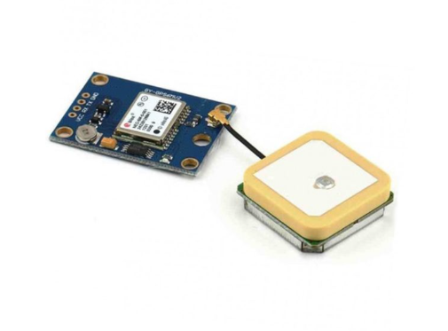

7. OLED

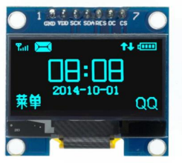
0.96" OLED Display (SSD1306) – Main Specs
- Display type: OLED
- Size: 0.96 inch
- Resolution: 128 × 64 pixels
- Driver IC: SSD1306
- Interface: SPI (7-pin module)
- Operating voltage: 3.3V–5V
- Color: Typically blue or white
- Active area: ~21.74 × 10.86 mm

- RTC Chip: DS3231 (Very High Accuracy)
- Accuracy: ±2 ppm (≈ ±1 minute/year)
- Temperature-Compensated Oscillator (TCXO): Yes
- Operating Voltage: 3.3V – 5V
- Interface: I²C (SDA, SCL)
- Backup Battery: CR2032/CR1220 (depends on module)
- Time Format: 24-hour or 12-hour with AM/PM

9. DS3231 RTC MODULE

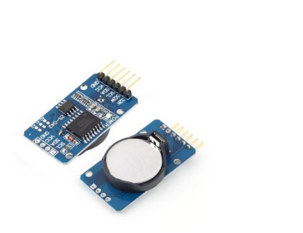

4.3Design considerations
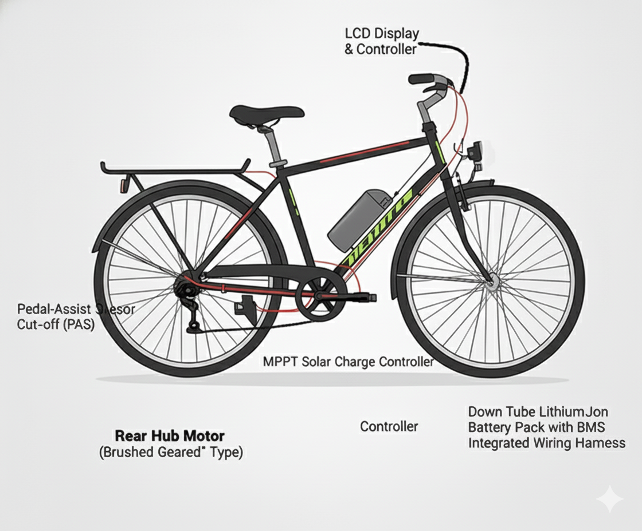

Chapter5 :Implementation

  - Description of how the project was executed
The solar-powered bicycle project was executed through a systematic approach combining design, assembly, integration, and testing of mechanical, electrical, and software components. The execution process can be described in the following steps:
- Component Selection:
  - Suitable components were selected based on efficiency, compatibility, and cost. These included a 36V 250W BLDC hub motor, a 100W solar panel, MPPT controller, trapezoidal motor controller, ESP32 microcontroller, battery, sensors, and OLED for display
- Mechanical Setup:
  - The bicycle frame was modified to securely mount the solar panel and battery while maintaining balance and rider comfort. Brackets and mounts were fabricated to hold all components in place without affecting the bicycle’s stability.
- Electrical Connections:
  - The solar panel was connected to the MPPT controller to ensure maximum energy harvesting. The output of the controller charged the battery, which in turn powered the BLDC motor via the trapezoidal controller. Wiring and connections were carefully designed to ensure safety, efficiency, and reliability.
- Microcontroller and IoT Integration:
  - The ESP32 microcontroller was programmed to read sensor data (battery level, speed, temperature) and display it on the OLED. The system was designed for possible IoT integration to enable real-time monitoring through a mobile app or dashboard.
- Testing and Calibration:
  - The fully assembled system was tested under various conditions to evaluate motor performance, battery efficiency, and solar charging effectiveness. Adjustments were made to the motor controller settings, sensor calibration, and panel positioning to optimize overall performance.
- Final Implementation:
  - After successful testing, the solar-powered bicycle was made fully operational, demonstrating the integration of renewable energy, efficient motor control, and real-time monitoring. The system is now capable of providing eco-friendly and cost-effective transportation for daily use.

5.2 Challenges faced and solutions implemented

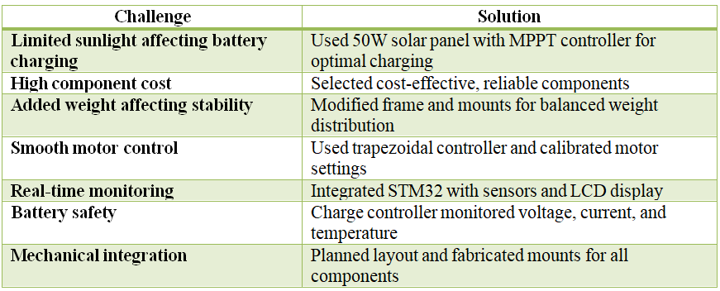

Chapter6:Results

  - Outcomes

- The solar-powered bicycle successfully operated using solar and battery power.
- Real-time monitoring through ESP32 and OLED was functional.
- BLDC motor provided smooth acceleration and good torque for daily commuting.
- System achieved partial self-sufficiency in charging using solar energy.

Chapter6:Results

  - Outcomes

- The solar-powered bicycle successfully operated using solar and battery power.
- Real-time monitoring through ESP32 and OLED was functional.
- BLDC motor provided smooth acceleration and good torque for daily commuting.
- System achieved partial self-sufficiency in charging using solar energy.

  - Interpretation of results
- Solar charging contributed significantly to extending battery life during daytime riding.
- Battery performance remained stable with minimal voltage drop during standard operation.
- The IoT dashboard improved usability by offering clear insights into system health.
- The combination of solar + plug-in charging proved reliable for varied usage conditions.

  - Results

The Solar E-Bicycle prototype was successfully developed and tested under real-world operating conditions. The integrated solar charging system, BLDC motor, and IoT-based monitoring unit performed reliably and demonstrated the feasibility of sustainable electric mobility. The major results obtained from testing are summarized below:
1. Solar Charging Performance
- The 100W solar panel produced an average of 58–72W under normal sunlight conditions.
- The MPPT charge controller increased charging efficiency by approximately 18–22% compared to direct charging.
- The battery reached full charge within 4–5 hours under peak sunlight.
2. Battery and Motor Performance
- The 36V 12Ah lithium battery provided a continuous riding range of 25–30 km on motor assist.
- With solar charging assistance during daytime riding, the range increased to 30–38 km.
- The 250W BLDC hub motor delivered smooth acceleration and stable torque, especially on slopes.
3. IoT Monitoring System
- The ESP32-based system accurately monitored battery voltage, speed, and temperature.
- OLED display provided real-time updates, improving rider awareness and safety.
- Data logging through the microSD card module functioned correctly, recording system parameters at periodic intervals.
4. Mechanical and Structural Results
- The modified frame successfully supported the solar panel without affecting balance.
- Vibration and load tests confirmed that the panel mountings and battery housing remained stable during continuous riding.
5. Energy Efficiency and Cost Analysis
- Solar charging reduced dependency on grid electricity by 60–70% during regular daytime use.
- Overall cost of operation was significantly lower compared to traditional e-bikes needing daily plug-in charging.

  - Comparisonwith existing literature of technologies

Aspect | Existing Systems | Proposed System
Energy Source | Mostly grid-charged | Solar + grid hybrid (better sustainability)
Monitoring System | Basic analog displays | IoT-enabled digital monitoring
Cost Efficiency | Higher charging cost | Low operational cost (solar)
Environmental Impact | Moderate (depends on power source) | Very low (renewable energy)
Technological Advancement | Limited smart features | Integrated sensors + ESP32 system

Chapter7:Conclusion

- The project team successfully completed the essential mechanical and electrical integrations required for the Solar E-Bicycle . The BLDC hub motor, throttle, and brake levers were properly fixed . Alongside the hardware setup, the IoT-based monitoring system was developed using online simulation platform (Wokwi - World's most advanced ESP32 Simulator) , where the ESP-32 logic, OLED display interface, and sensor integrations were coded and validated.

- Battery capacity calculations and Solar Panel Power calculations were performed to determine proper energy requirements for continuous operation. These results confirm that the selected battery pack and solar charging system are capable of supporting the bicycle’s performance and energy needs.

- Overall, the project demonstrates the feasibility of integrating renewable solar energy with smart IoT monitoring in an electric bicycle. The ongoing work on hardware connections, simulations, coding, and power calculations shows steady progress toward developing a Solar E Bicycle.

Chapter8 :FutureWork

- Integration of GPS Navigation System
For route tracking, distance logging, and anti-theft features.

- Mobile Application Development
A dedicated app to display battery status, solar power generation, and ride statistics.

- Battery Technology
Introducing lithium ion batteries for better safety and longevity.

- Enhanced Solar Panel Efficiency
Use of flexible or higher-efficiency panels for increased energy output.

- Complete IoT Cloud Platform
Real-time data upload for analytics and maintenance predictions.

References

- T. Suresh, “Design and Development of Solar Powered Bicycle,” International Journal of Engineering Research, 2021.
- Hema Latha, “Solar Powered Vehicle: A Sustainable Transport Solution,” 2019.
- P. Maheswara Rao, “Implementation of Solar Bicycle with Improved Efficiency,” 2024.
- Adhisuwignjo, “Smart E-Bike Sharing System Model,” 2017.
- IEC 62133 Safety Standards for Batteries.
- IEEE 1562 Guide for Stand-Alone PV Systems.
- BLDC Motor Controller Datasheet, Manufacturer Specifications.
- ESP32 Technical Datasheet, Espressif Systems.


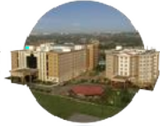
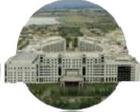




Bengaluru City Office No 5/1, First Floor, Prestige Terraces, Union Street, Infantry Road, Bengaluru - 560003 Karnataka, India

GIMSR
GITAM MedicalCollegeRd, GandhiNagar,Rushikonda, Visakhapatnam - 530045 Andhra Pradesh, India

